SYMBIOSIS, MUTUALISM, PARASITISM, AND MORE
Relationships in Ecosystems Chart

Directions: 1) Use each Canopy In The Clouds media clip given and examine the organisms in different relationship. Write down the organisms participating and a brief statement about what they are doing.
2) Decide who is benefitting from the relationship and write the name of the organism in the appropriate column. Determine if any organism is harmed, or unaffected and write the name in the appropriate column.
3) If there is no organism benefitting from the relationship, write “none” in the column. Each column has a possibility of 0-2 answers.
4) Leave the “Type of Relationship” and “Importance” column blank until given instructions from your teacher.

Canopy In The Clouds Media | Organisms in the relationship | Explain the relationship | Who is benefitting? + | Who is harmed?  - | Who is unaffected? 0 | Type of Relationship | Importance
Panorama #3  Canopy Hotspot #1  Microclimate & Plants | Trees and orchids | Orchids are growing on the branches & stems of trees | Orchid | None | Trees | Commensalism | Orchids cannot survive on forest floor. Would die without trees to grow on.
Strangler Fig video clip

Panorama #1
Hotspot #7
Leaf Cutter Ants

Panorama #2 Hotspot #1
Site Introduction

SYMBIOSIS, MUTUALISM, PARASITISM, AND MORE
Relationship Concept Map

Directions: Use the terms provided on the index cards to fill in the concept map. Provide examples of each type of symbiotic relationship.

Example:
Example:
Example:
Example:
Example:
Example:
SYMBIOSIS, MUTUALISM, PARASITISM, AND MORE
Student Assessment: Symbiotic Relationships

Question 1
Directions: 1) Examine the picture below and read the accompanying text. Identify the organisms participating in a symbiotic relationship and whether the organism benefits, is harmed, or is unaffected.
2) Name the type of symbiotic relationship experienced between the organisms.

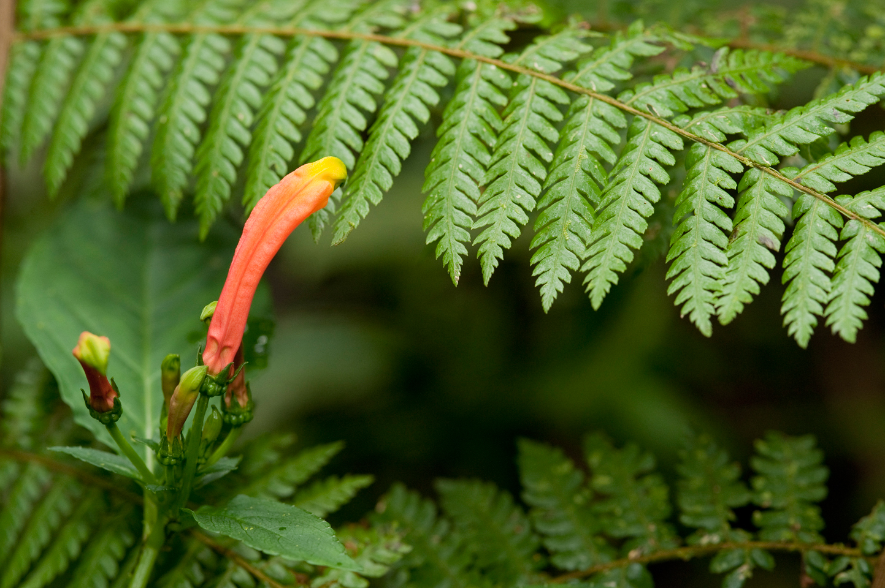 | These beautiful understory plants have brightly-colored flowers in the shape of tubes. This particular form of flower is often associated with pollination by hummingbirds. These flowers are often home to hummingbird mites, tiny animals related to spiders, which hitch rides from flower to flower in the nostrils or mouth of the hummingbird as it flies. The mites feed on the flower nectar and mate in the folds of the flower.

Relationship #1 | Organism #1 Name: | Organism #2 Name: | Type of Symbiosis:
Relationship #1 | Benefit, Harmed, Unaffected: | Benefit, Harmed, Unaffected: | Type of Symbiosis:
Relationship #2 | Organism #1 Name: | Organism #2 Name: | Type of Symbiosis:
Relationship #2 | Benefit, Harmed, Unaffected: | Benefit, Harmed, Unaffected: | Type of Symbiosis:
Relationship #3 | Organism #1 Name: | Organism #2 Name: | Type of Symbiosis:
Relationship #3 | Benefit, Harmed, Unaffected: | Benefit, Harmed, Unaffected: | Type of Symbiosis:

Question 2
- Think about the relationship between the hummingbird and the mite from Question 1. Explain the importance of this relationship to the cloud forest ecosystem.

- Think about the relationship between the hummingbird and the flower from Question 1. Explain the importance of this relationship to the cloud forest ecosystem.

- Think about the relationship between the flower and the mite from Question 1. Explain the importance of this relationship to the cloud forest ecosystem.

Question 3
Directions: Choose two of the three types of symbiosis that you have learned about in this lesson- mutualism, commensalism, or parasitism- and complete the Venn diagram below. Be sure to clearly label the circles, discuss the similarities and differences between the two relationships, and include examples.

SYMBIOSIS, MUTUALISM, PARASITISM, AND MORE
Student Assessment: Symbiotic Relationships
Answer Key and Rubric
Question 1
Relationship #1 | Organism #1 Name:  Hummingbird | Organism #2 Name:  Mite | Type of Symbiosis:  Commensalism
Relationship #1 | Benefit, Harmed, Unaffected:  Unaffected | Benefit, Harmed, Unaffected:  Benefits by gaining mobility from bird | Type of Symbiosis:  Commensalism
Relationship #2 | Organism #1 Name:  Hummingbird | Organism #2 Name:  Flower | Type of Symbiosis:  Mutualism
Relationship #2 | Benefit, Harmed, Unaffected:  Benefits by gaining nourishment from flower | Benefit, Harmed, Unaffected:  Benefits by being pollinated by bird | Type of Symbiosis:  Mutualism
Relationship #3 | Organism #1 Name:  Mite | Organism #2 Name:  Flower | Type of Symbiosis:  Commensalism
Relationship #3 | Benefit, Harmed, Unaffected:  Benefits by gaining nourishment and mating location | Benefit, Harmed, Unaffected:  Unaffected | Type of Symbiosis:  Commensalism
1 point for each box → 15 total

Question 2

- Without the hummingbird, the mite would not be mobile enough to reach the flower that provides food and a location for reproduction. The mite population would either decline from lack of nourishment and ability to reproduce or the species would adapt to utilize a new method of mobility.
- Without the hummingbird to pollinate this species of flower, the plant population would either fail to reproduce and/or the species would adapt in order to develop a new method of reproduction.
- Without the flower, the mite will loose its source of nourishment and mating location. The mite population would either decline from or the species would need to adapt to new food sources and mating locations.
Specific answers will vary. (3 points each)

Question 3
Specific examples will vary
1 point for description in each section → 3 points
1 point for example in each section → 3 point

Total Score = ______ / 30
- 29- 30 points | Mastery – You have a strong understanding of the lesson objectives.
- 24 – 28 points | Proficient - You’re almost there!
- 18 – 23 points | Beginning Proficiency – You are starting to understand.
- 0 - 17 points | Needs Improvement – You made several mistakes. Ask for help and keep practicing.

