SOIL NUTRIENT CYCLING
Imagine this scene: You arrive in Monteverde, Costa Rica, eager to explore the cloud forest. As you approach the outskirts of the forested area, however, something appears to be wrong. The huge quantity of fallen leaves, tree branches, and dead insects on the forest floor has created a carpet of detritus that is over a meter thick! The trees and other plants look scrawny and their leaves are yellow, pale, and dying along the margins. You struggle to walk deeper into the forest, but your feet are mired in the detritus that covers the ground. Exhausted, you haul yourself back out of the forest, puzzled and dismayed by this bizarre state of affairs.
What was happening to this forest? It lacked the billions of soil organisms that play a big role in nutrient cycling in the cloud forest! Soils that lack these nutrient cyclers experience an overload of detritus because of slowed decomposition. These soils also have a shortage of essential elements available to plants due to a lack of organisms that make such substances available.
Detritus
First, let’s take a closer look at the detritus that exists in the cloud forests of Monteverde. Navigate to Panorama #1 (low elevation forest), stay on the ground (as opposed to going up to the canopy), and watch video #5. You can also visit any panorama and zoom in on the forest floor to view detritus. After watching the video and exploring other panoramas, answer the questions below.
(1) What is “leaf litter”? __________________________________________________________
______________________________________________________________________________
(2) What effect might dry leaf litter have on the growth of plants in a given area? Explain.
__________________________________________________________________________________________________________________________________________________________________________________________________________________________________________

Decomposition
Next we will view evidence of decomposition in these forests. Decomposition is the process by which organic matter is broken down into simpler matter. Navigate to Panorama #2 (mid-elevation forest) and watch ground video #5 to view a rotting log on the forest floor.
(1) Describe what you see: ________________________________________________________
__________________________________________________________________________________________________________________________________________________________________________________________________________________________________________

Now visit Panorama #3 (high elevation forest), and watch ground video #5, then navigate up to the canopy to view video #2. After watching these two videos, answer the question below.
(1) What role do decomposers play in the forest canopy? _______________________________
____________________________________________________________________________________________________________________________________________________________

The Nutrients
While plants need many nutrients to thrive, here we will focus on three that are critical to their survival: carbon, nitrogen, and phosphorus. These substances are elements, the basic building blocks of all matter.
Carbon is an element that is an essential component of cells. In order for a plant (or anything organic) to grow, it must have access to carbon. Plants take in carbon directly from the atmosphere, in the form of carbon dioxide (CO₂). Carbon dioxide is a molecule that plants can convert into sugar for energy through photosynthesis. Atmospheric carbon dioxide has many sources, a primary one of which is decomposers that break down organic matter in the soil.
Nitrogen is an element that is also a part of all cells. Proteins, DNA, and chlorophyll—chemical compounds that are essential to a plant—contain nitrogen. Our atmosphere is about 78% nitrogen, but this is in the form of nitrogen gas (N₂), which plants cannot use directly. In order for plants to use nitrogen, it must be in the form of nitrate (NO₃⁻) or ammonium (NH₄⁺). Nutrient cyclers in the soil can convert nitrogen gas into those usable forms.
Phosphorus is an element that plants use in photosynthesis, respiration, and energy storage. Phosphorus is not readily available from the atmosphere, so plants must take it in through the soil. Phosphorous occurs in soil, breaking down from rocks and becoming available over time. Then it is cycled through leaves after they die and decompose, making the phosphorous available for the plant once again.
The Nutrient Cyclers
What organisms are soil nutrient cyclers? There are a few macroscopic organisms such as certain worms and insects, which can be seen on and in the soil quite readily. In fact, you observed several of these in the rotting log video. However, most soil nutrient cyclers are microscopic. One cannot dig through a pile of soil and see fungal cells or bacteria, even though there are billions of them in a tablespoon of soil, because they cannot be seen with the naked eye. Thankfully, microscopes allow us to view them in great detail.
(1) Insects
Insects cut up leaves into smaller pieces. They may ingest the leaf bits, later passing nutrient material out as excrement, or they may cut the leaves apart for a different purpose. However, when leaves are cut into smaller pieces, they have more exposed surface area, and the greater the exposed surface area, the more efficiently other decomposers can continue to break them down. Mites, beetles, and ants are excellent examples of such cloud forest decomposers. Some of these insects spend time on the ground as adults, and many spend time in the soil as larvae. These insects also contribute to the decomposition of detritus up in the canopy.
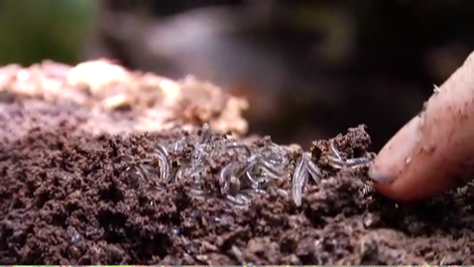
Visit the “Media” page and select “Photographs”. Look through the “Bugs on White –Beetles” album.
(1) Find a beetle in the album that looks like it ingests or cuts up leaves. What physical features lead you to believe the beetle uses leaves in this way?
____________________________________________________________________________________________________________________________________________________________

(2) Worms
Worms spend time on and under the ground in the cloud forest. They feed on detritus, breaking down the organic compounds into smaller, more readily usable nutrients in their digestive tracts. Any nutrients that are not retained in their bodies are excreted back into the soil. Worms also tunnel through the soil, leaving aerated passages in their wake. Exposure to air can speed up the decomposition process, since most organisms need oxygen, so worms play this second role in cloud forest decomposition as well.
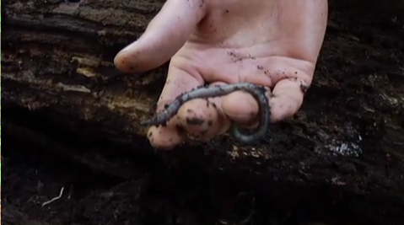

Explore more!
Visit http://www.naturewatch.ca/english/wormwatch/virtual_worm/index.html to take a tour through the digestive tract of an earthworm.

(3) Bacteria
Bacteria are single-celled organisms. Bacteria can be found on and in almost everything on Earth, including soil. Bacteria perform two important roles in the soil: they decompose organic matter and they make nitrogen available to plants. The decomposer bacteria, or actinobacteria, digest detritus. They use some of the nutrients in the detritus for their own growth and metabolism, but the process creates several byproducts that are useful to plants. Carbon dioxide (CO₂) is one of these byproducts. Without soil bacteria, much of the carbon that is “locked” in organic matter would remain inaccessible to plants, and plant communities would experience negative effects. Even though you cannot see individual actinobacteria with the naked eye, there is another way to detect their presence in the soil. Freshly turned soil has a distinct, earthy smell, called geosmin. Geosmin is the result of a chemical compound produced by actinobacteria, so you can use your sense of smell to detect them!
Explore more!
To see photos of actinobacteria and learn more, go to http://www.eol.org/pages/7861.

Nitrogen-fixing bacteria are bacteria that can take nitrogen gas (N₂) from the atmosphere and convert it to nitrate (NO₃⁻) or ammonium (NH₄⁺), forms of nitrogen usable by plants. These bacteria can live throughout the soil, or may be integrated into a plant’s root system in a symbiotic relationship. In fact, the roots of orchids throughout the cloud forest are infected with nitrogen-fixing bacteria!
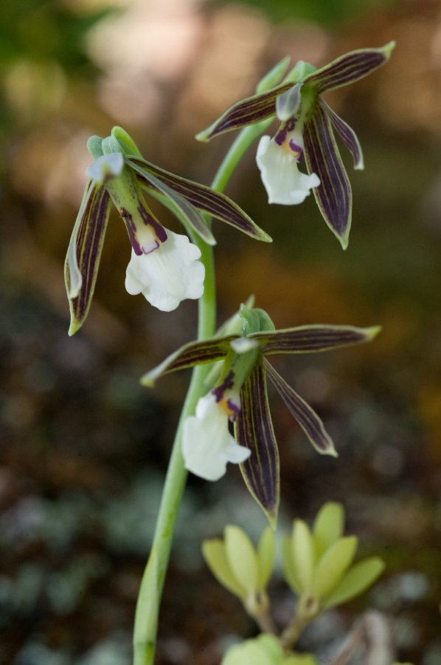
Explore more!
Visit http://videos.howstuffworks.com/hsw/27263-the-cycle-series-legumes-video.htm to watch a video about nitrogen-fixing bacteria and the nitrogen cycle.

(4) Fungi
Fungi are incredibly diverse and a massive kingdom of organisms. They may be unicellular or multicellular, and can live aboveground and belowground. Fungi are heterotrophic, meaning that they must feed on other organic matter for energy. Moreover, many fungi are saprophytic, feeding on dead organic matter and returning nutrients to the soil as they break them down. In addition, these fungi can help hold nutrients in the soil, preventing them from being washed away before a plant makes use of them.
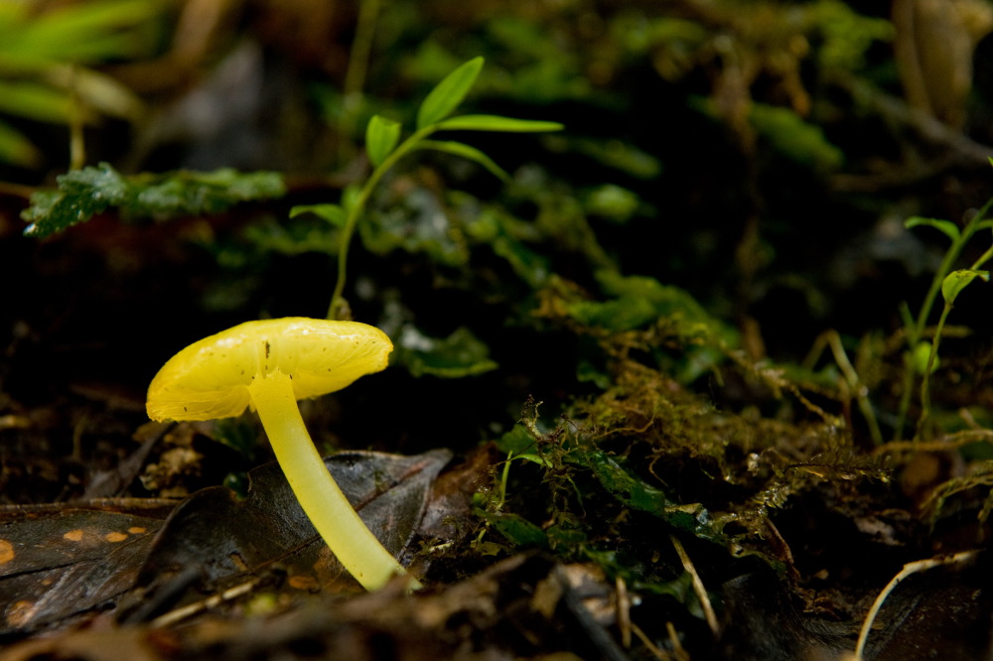
Explore more!
Visit http://www.hiddenforest.co.nz/fungi/class/how.htm to learn more about different types of fungi.

Mycorrhizal fungi are a particular group that forms a symbiotic relationship with plants. Many, many plants and trees have some mycorrhizal fungi associated with them! These fungi use carbon from the plant as an energy source, while facilitating uptake of nutrients (i.e. phosphorous) and water to the plant via the roots. Mycorrhizal fungi can form vast fungal networks that stretch meters—sometimes miles—through the soil.

Explore more!
Visit http://www.youtube.com/watch?v=bq1bTduTzC0 to watch a video about how mycorrhizae obtain and transfer phosphorus.

