WATER CYCLE IN THE CLOUD FOREST
Student Observations

Where do I see or experience water around me?
Examples: | Step in the water cycle:

Canopy In the Clouds Water Cycle video
Observations of water: | Name of water cycle step given by scientist and explanation:
Water leaves the earth’s surface! | Evaporation. Driven by the sun’s energy, which heats liquid water and causes a phase change to steam.

WATER CYCLE IN THE CLOUD FOREST
Water Cycle Diagram

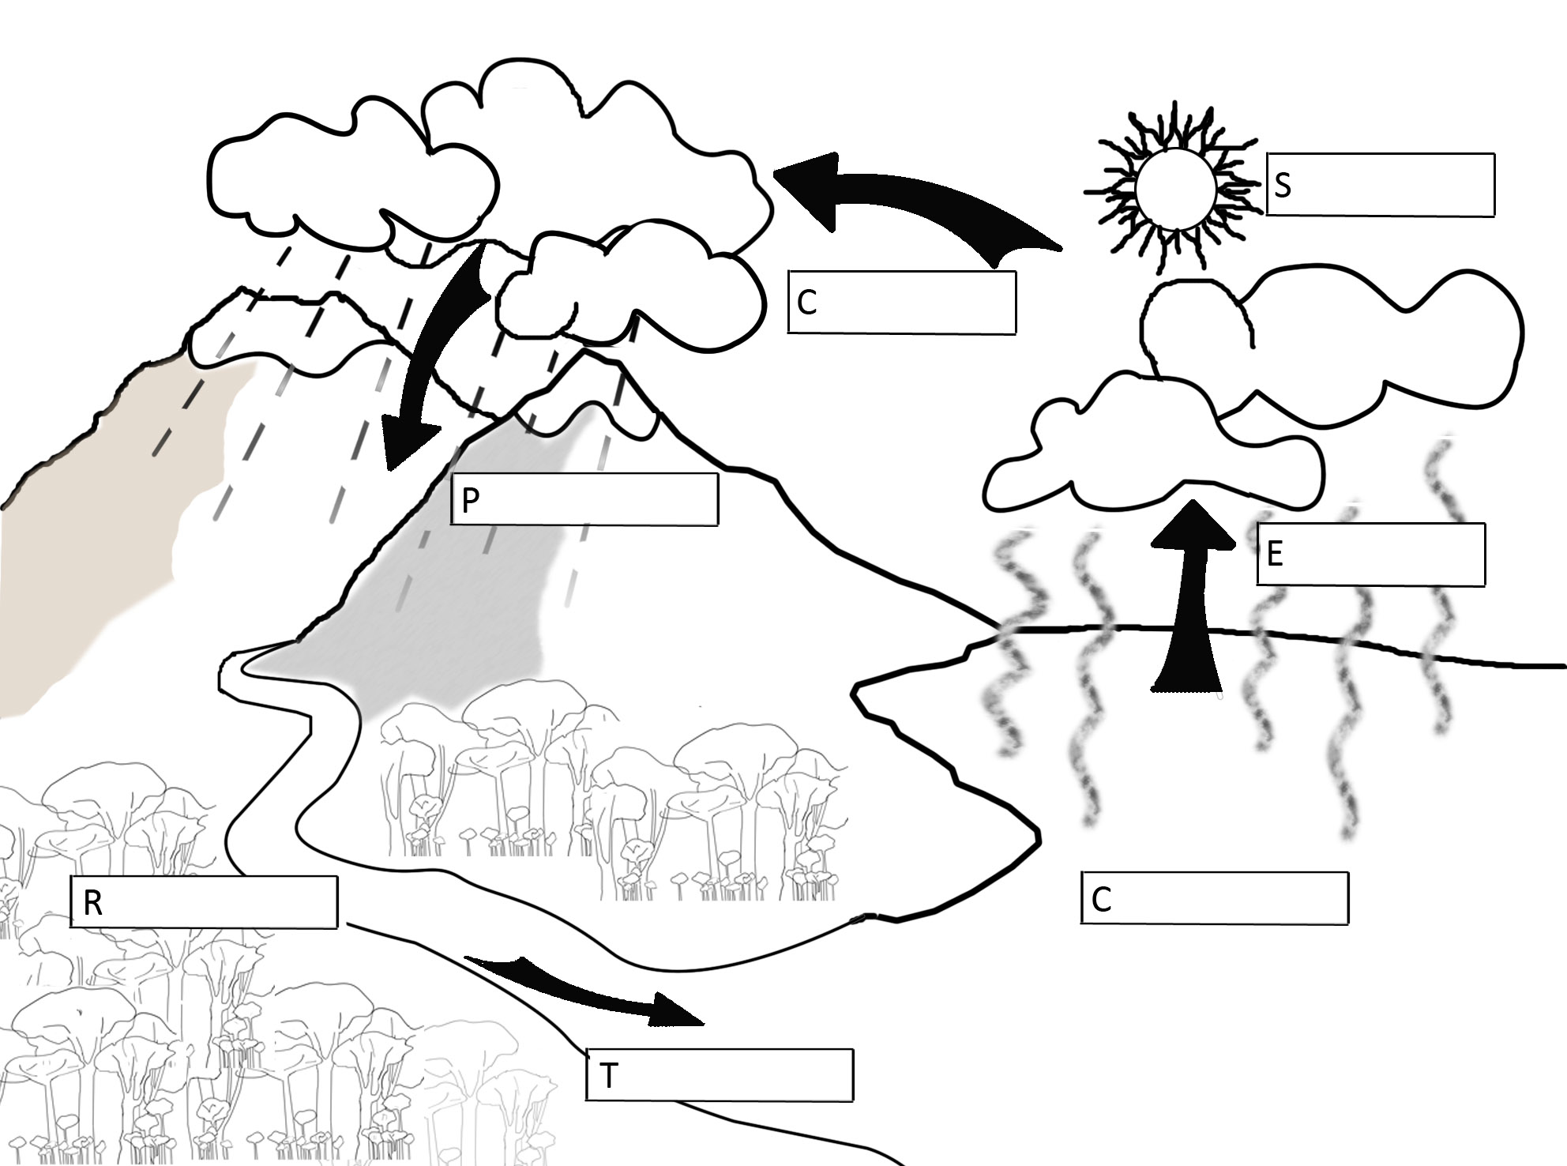

Demonstration drawing and labels:

WATER CYCLE IN THE CLOUD FOREST
Student Assessment: Steps of the Water Cycle

Directions: Examine the diagram below. Determine where each step of the water cycle is occurring and label it. Explain each label as well.

